Kiama Women Golfers

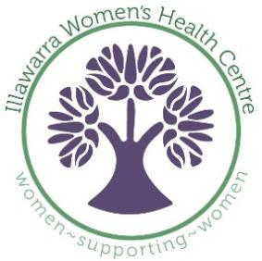
Charity Golf Day
Wednesday 8th June, 2022
- Coloured Ball
- Teams of four
- Each team has one coloured ball used by each team member in turn, changing after each hole. For example, on the first hole Player A hits the coloured ball; on the second hole, Player B plays the coloured ball, and so on, rotating throughout the round.
- At the completion of each hole, the scores of two team members are added together to create one team score. One of those scores must be from the player who used the coloured ball. The other score is the best score among the other three team members.
- Lunch will be available for purchase at the club

ENTRY FEE: $20 per person ENTRIES CLOSE: Late entries will be accepted

ENTRIES PLUS FEES TO: Email: kiama.ladies@gmail.com

Direct Payment: Kiama Golf Club Ref: Your Club
BSB: 012 709 A/c: 418 087 115
PLEASE NOTE: Refunds will not be available after the draw has been completed.
For Cart bookings please call Pro Shop Ph: 4237 7300

Names – Team of 4 |  | 1 Phone Contact |  | Club | G.A. H’cap | Golf Link No. | Preferred Tee Time | Tee Time (KGC to advise)
1.
2.
3.
4.
1.
2.
3.
4.

