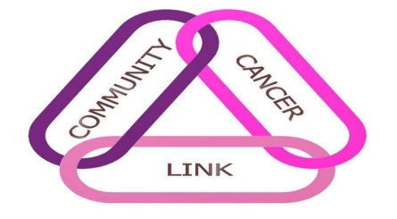
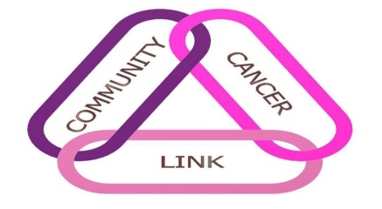

JAMBEROO WOMENS
COMMUNITY CANCER LINK CHARITY DAY 2022
3 person Las Vegas Ambrose

 | DATE: | Tuesday 20th SEPTEMBER 2022  Shotgun START – 8.00 FOR 8.30 AM
 | ADDRESS: | Allowrie Street, Jamberoo
 | FEES: | $25 (includes game and LUNCH)
 | ENTRIES CLOSE: | Friday 16th September 2022

Please return entry form together and fees (preferably by cheque or EFT as below) to:
Marie Smith (Secretary), Jamberoo Golf Club PO Box 112, JAMBEROO NSW 2533
Phone: 0407 280 484 Email: smithmarie59@yahoo.com.au, or
Judi O'Brien (Captain) Phone: 0402 240 650 Email: judi_obrien@hotmail.com
Electric carts available for hire from Pro Shop - Contact 4236 0404

 | CLUB:
 | TEAM CONTACT NAME: |  |  |  | MOBILE:
 | EMAIL:
 | Name: |  |  | GA H'cap: |  | Golflink No:
 | 1:
 | 2:
 | 3:
 | 4:
 | 5:
 | 6:
 | EFT Details:
 | IMB Bank - BSB No. 641 800 |  |  |  |  |  | A/C No. 200197021
 | Cheques should be made payable to Jamberoo Women’s Golf Club

