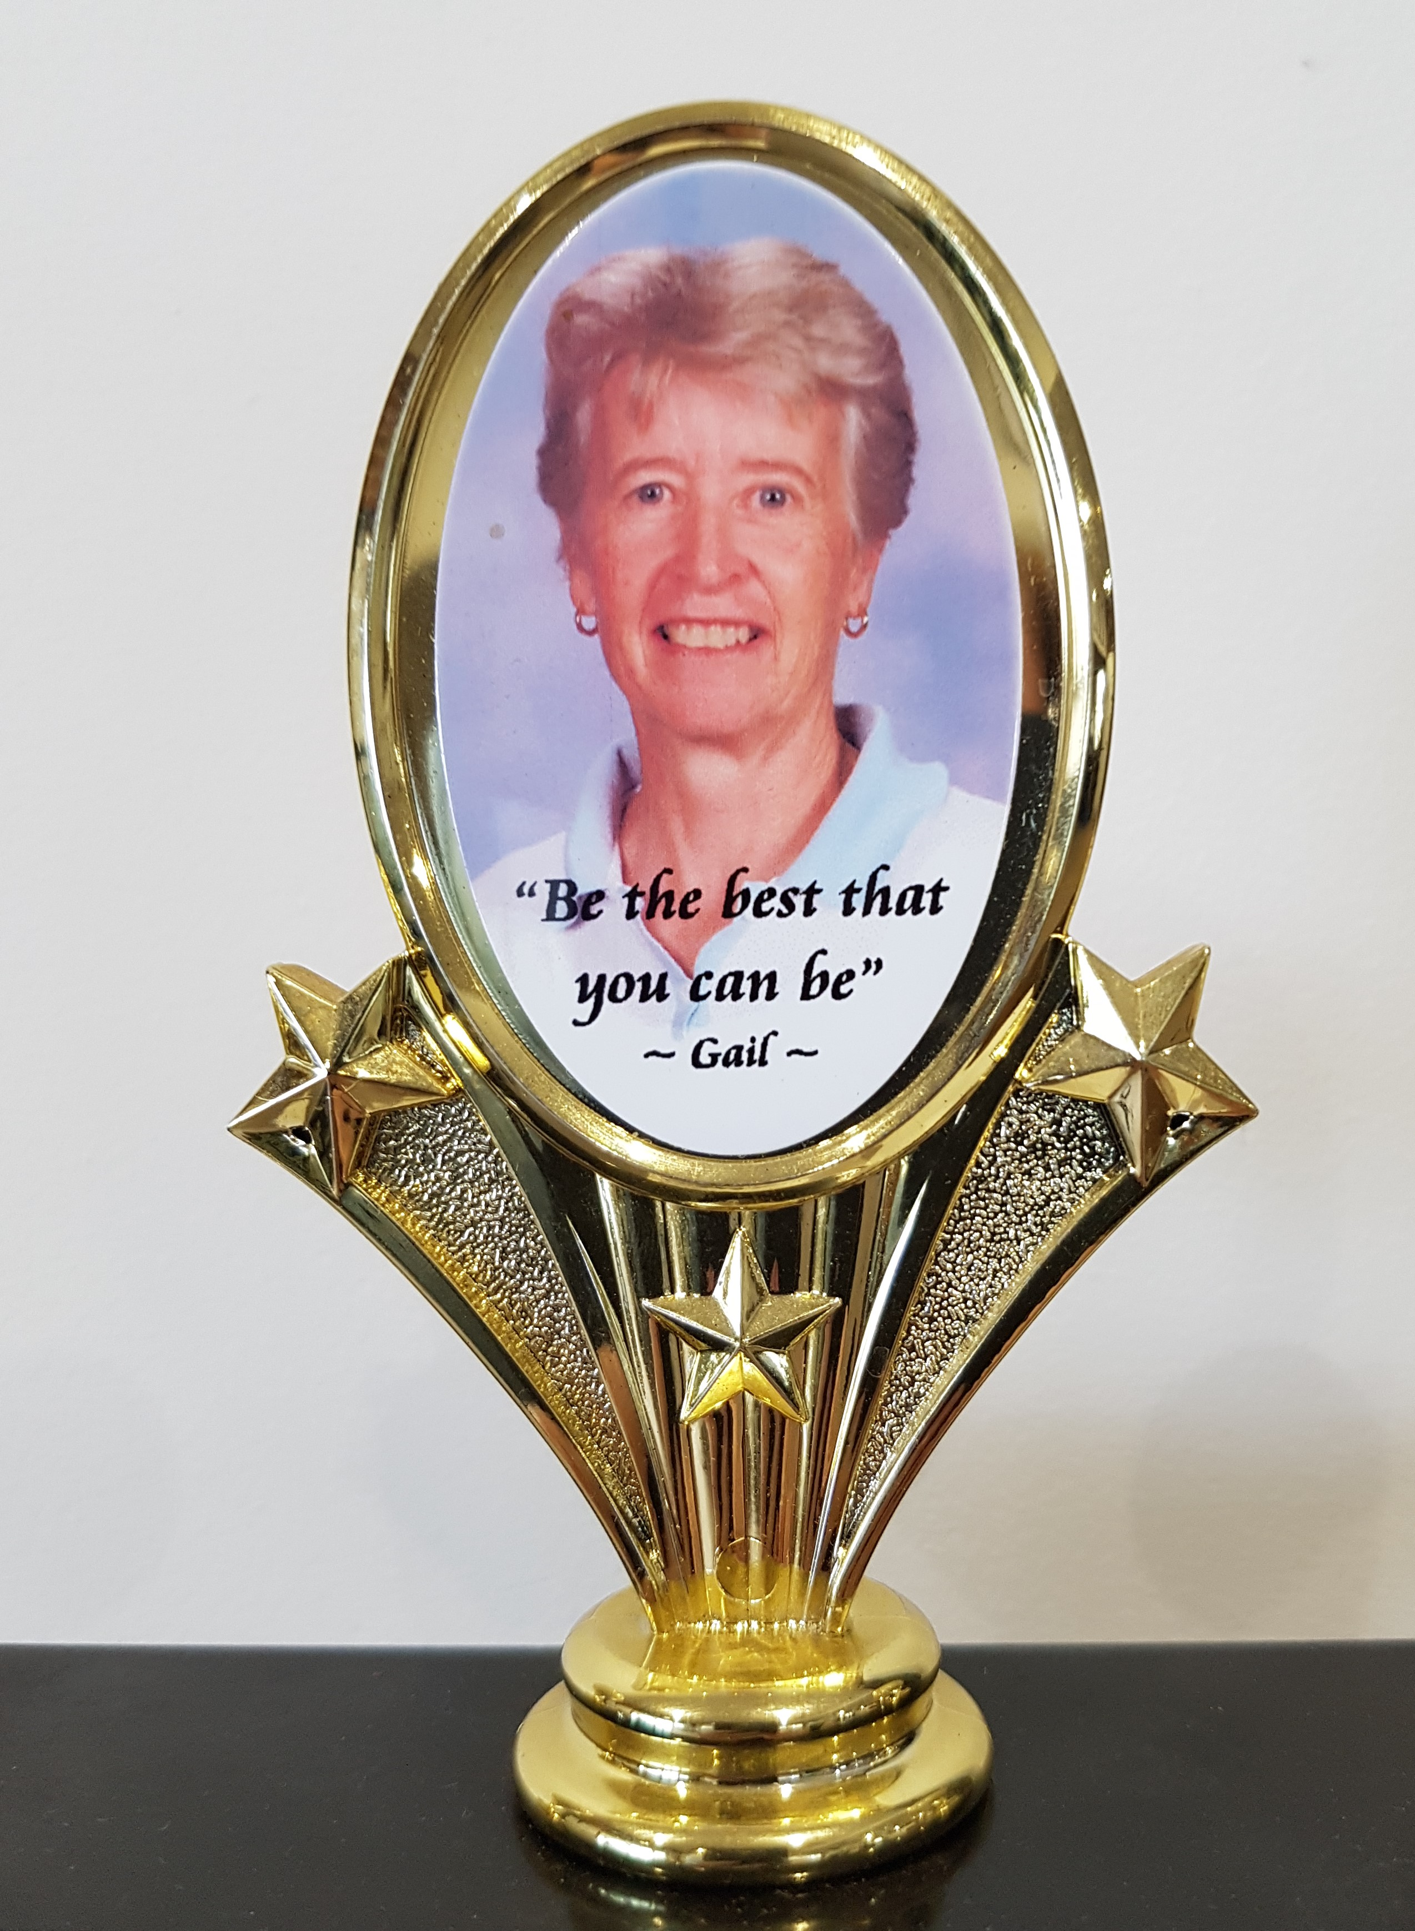
WOMENS GOLF GERRINGONG

GAIL BURGIN
MEMORIAL TROPHY

THURSDAY, 4 SEPTEMBER, 2025
SHOTGUN START: 8.30AM
ENTRIES CLOSE: WEDNESDAY, 27 AUGUST, 2025

18 HOLE STABLEFORD EVENT
ENTRY FEE: GAME & LUNCH $50

Carts available for hire from Pro Shop to book a cart phone 4234 3333 - $50 per cart
- payable on the day by card only.

PLAYER | GOLF LINK NO. | HCP | CONTACT | CART/SHARING
PAYMENT by EFT please, to:-
ANZ. BSB: 012628. A/c: 2572 27454.
GERRINGONG LADIES GOLF.
EMAIL ENTRIES TO: gerringongladiesgolf@hotmail.com
No refunds will be issued within one week prior to the game unless cancelled by Committee.
Please advise, any special dietary requests gluten/vegetarian.

