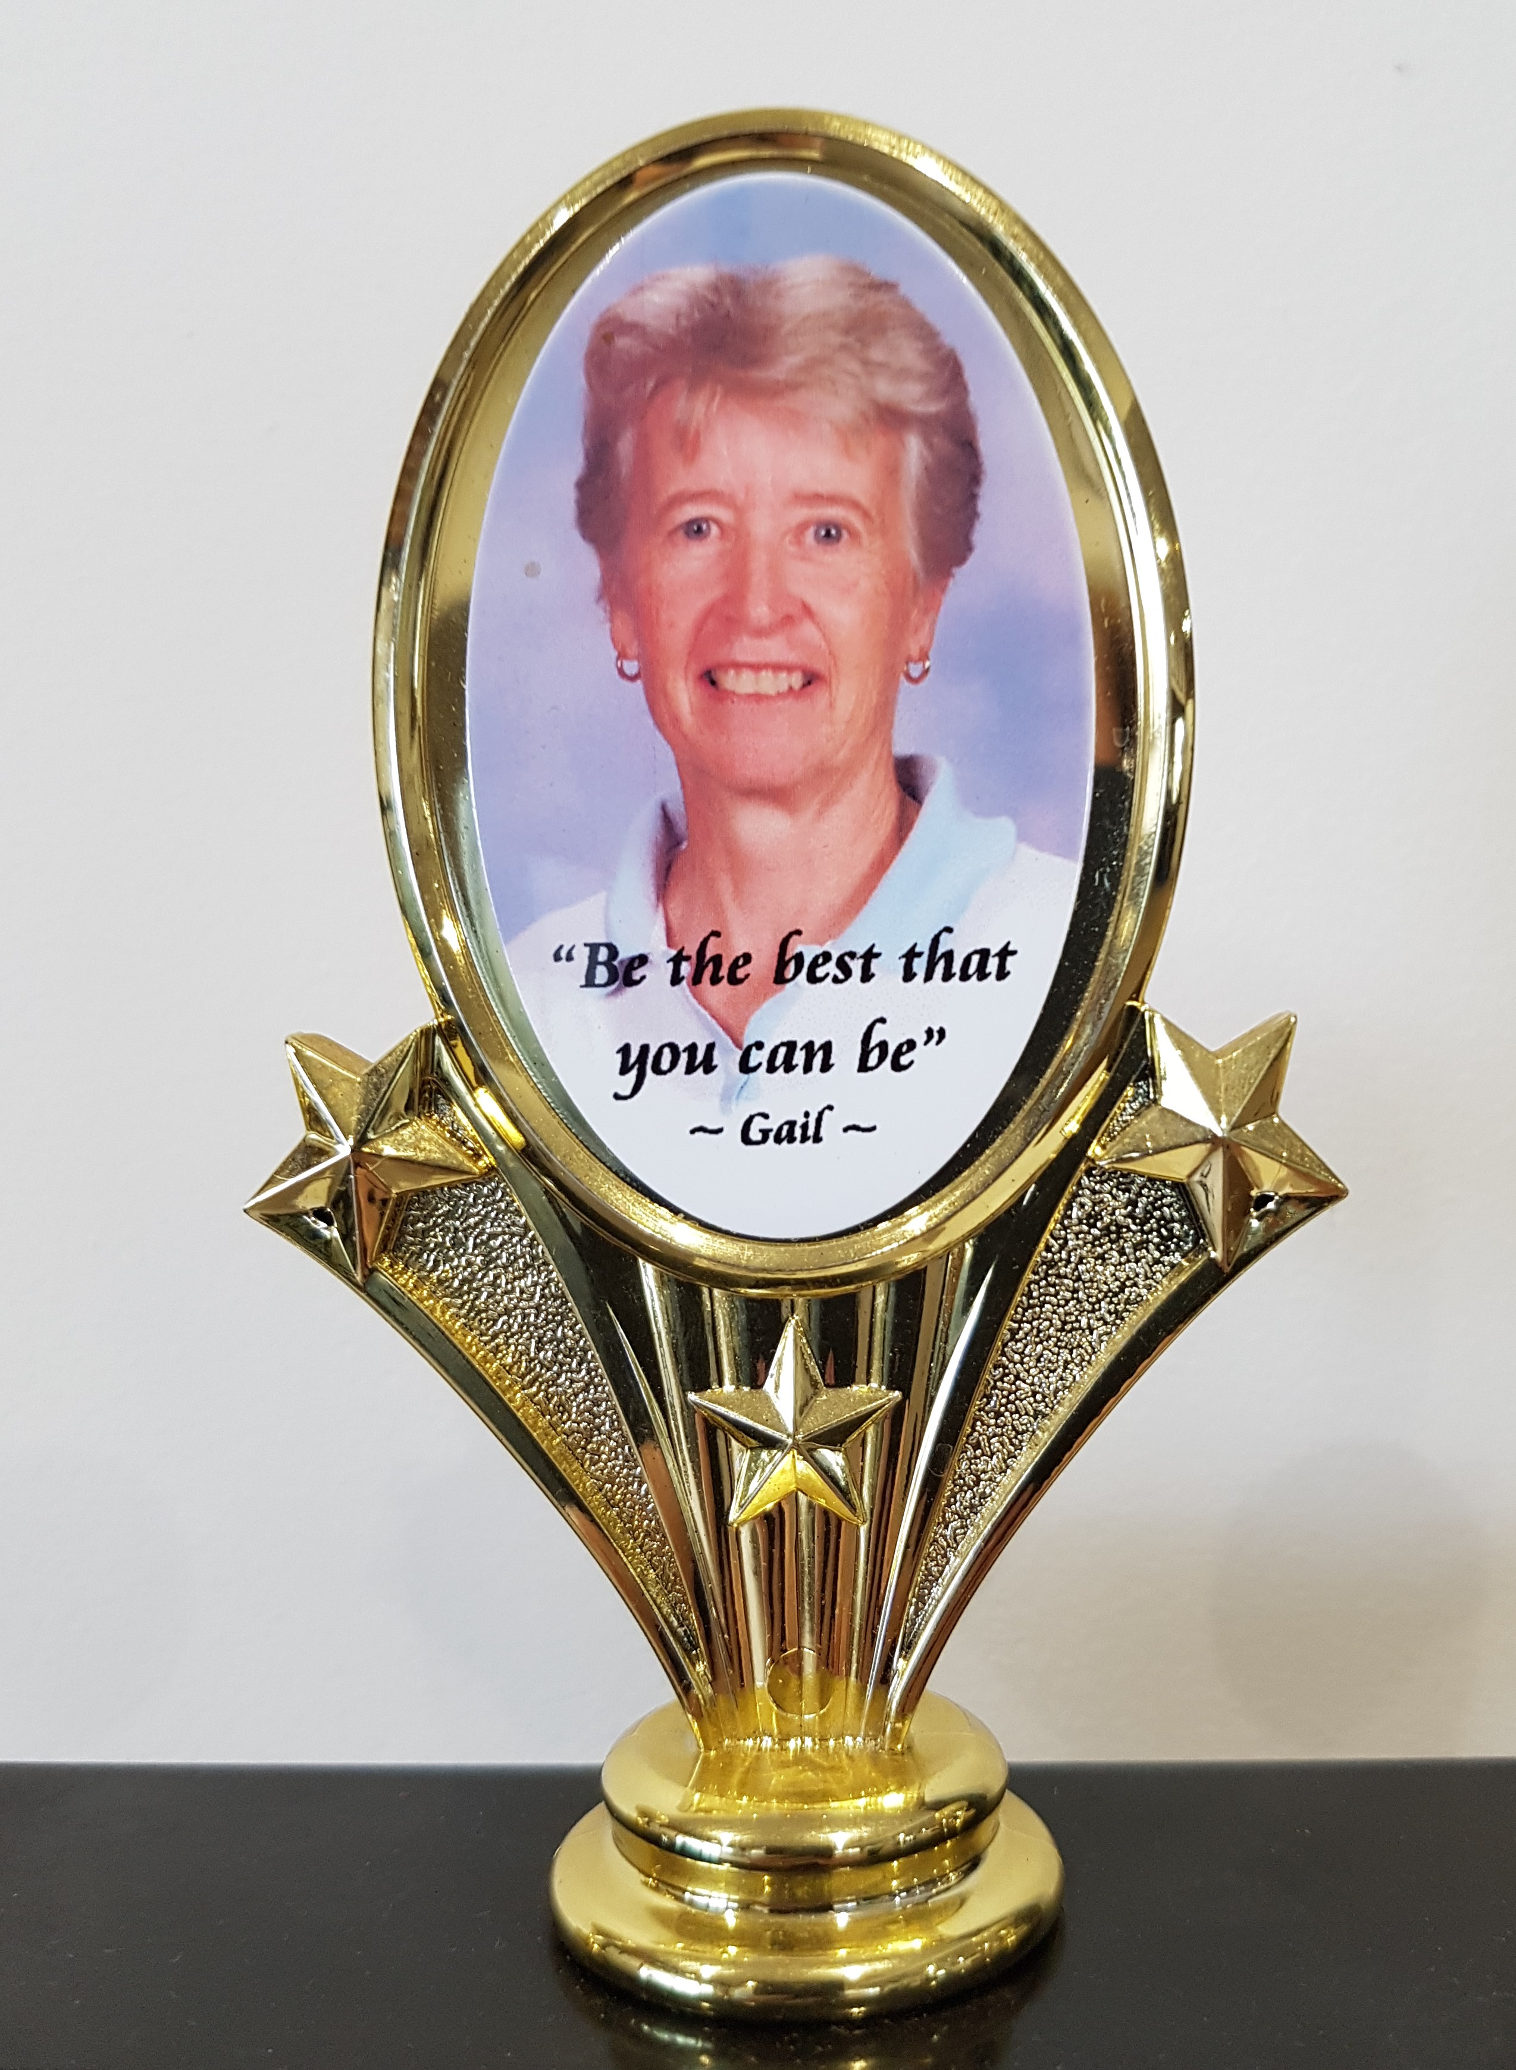
GERRINGONG GOLF CLUB
LADIES MEMBERS

GAIL BURGIN
MEMORIAL TROPHY

THURSDAY, APRIL 20, 2023

SHOTGUN START: 8.30AM

ENTRIES CLOSE: WEDNESDAY APRIL 12, 2023

18 HOLE STABLEFORD EVENT

ENTRY FEE: GAME & LUNCH $40

Carts available for hire from Pro Shop, to book a cart phone 4234 3333 - $40 per cart
- payable on the day by card only.

PLAYER | GOLF LINK NO. | HCP | PHONE | CLUB

PAYMENT by EFT please, to:- ANZ. BSB: 012628. A/c: 2572 27454.
GERRINGONG LADIES GOLF.

EMAIL ENTRIES TO: gerringongladiesgolf@hotmail.com

No refunds will be issued within one week prior to the game unless cancelled by Committee.
Please advise, any special dietary requests: gluten/vegetarian.

