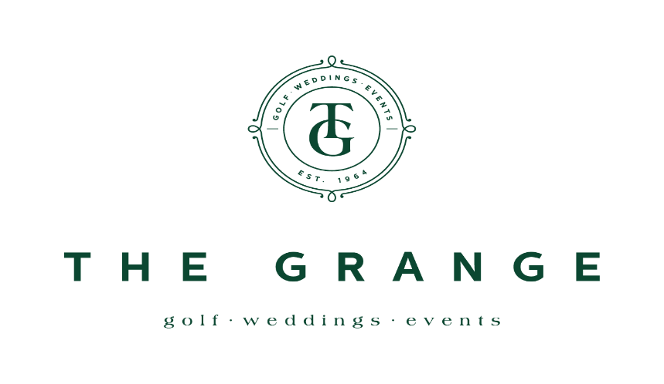

THE GRANGE LADIES OPEN – 18 HOLE STROKE
Jack Duggan Salver - Best Gross
Grange Bowl – Best Nett

WEDNESDAY 11th FEBRUARY, 2026
- Open to Lady Golfers with a Daily Handicap up to 54.
- Seeded Draw – Divisions based on Entries
- Gross and nett prizes (One prize per player)
- TIES for overall scratch winner decided by a sudden death playoff on 18th hole. Other ties decided by countback
PAYMENT TO BE MADE ON THE DAY OF PLAY
Entry Fee: $25 for Members $35 per Visitors
Event is prior to Gold and Silver Red Pennants at The Grange 2.3.26
Updated Course Layout. PAR 70 Slope rating 128
HOW TO ENTER
MEMBERS Enter via members MiClub Teesheet Portal
VISITORS Complete the information below and email form to proshop@thegrangegolfclub.com.au

NAME: _________________________________ HOME CLUB: ______________________
GOLF ID #: _________________________ GA Handicap: _______________
Contact Ph: _____________________ Email: ________________________________
Entries Close: Wednesday 4TH FEBRUARY, 2026
Draw to be released Thursday 5TH FEBRUARY, 2026
(Late entries accepted but may play at the end of the field)
For Cart bookings and queries contact Golf Shop for Ph 02 4261 1647

