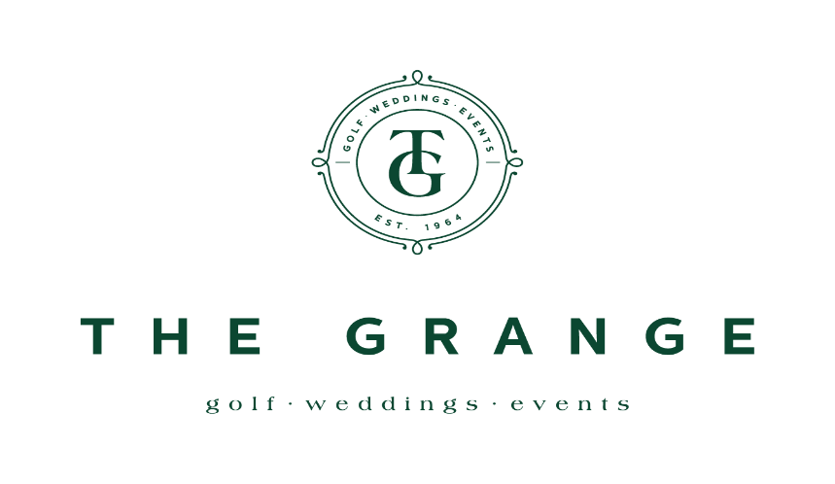

LADIES OPEN – 18 HOLE STROKE
Jack Duggan Salver - Best Gross
Grange Bowl – Best Nett

WEDNESDAY 10th APRIL, 2024
- Open to Lady Golfers with a Daily Handicap up to 54. Slope rating 128
- Seeded Draw – Divisions based on Entries
- Gross and nett prizes (One prize per player)
- TIES for overall scratch winner decided by a sudden death playoff on 18th hole. Other ties decided by countback
PAYMENT TO BE MADE ON THE DAY OF PLAY
Entry Fee: $25 per player
Event is prior to Gold, Silver and Bronze Pennant days at The Grange
Updated Course Layout. PAR 70 Slope rating 128
HOW TO ENTER
MEMBERS Enter via members MiClub Teesheet Portal
VISITORS Complete the information below and email form to proshop@thegrangegolfclub.com.au

NAME: ______________________________ HOME CLUB: _____________________
GOLFLINK #: ______________________ GA Handicap: ______
Contact Ph: _______________________ Email: ___________________________
Entries Close: Wednesday 3RD APRIL, 2024
Draw to be released Thursday 4TH APRIL 2024
(Late entries accepted but may play at the end of the field)
Please contact Golf Shop for any queries Ph 02 4261 1647

